

SEND Information Report

SENDCo – Mrs Emily Day send@williammorris.bluekitetrust.org
Designated teacher for Looked After Children – Mr Calum Boothroyd
SEND Governor – Chris Davies
Acronyms:

ATCL – Advisory Teachers for Cognition and Learning
ADHD – Attention Deficit Hyperactivity Disorder
EHCP – Education Health and Care Plan
EHR – Early Help Record
ELSA – Emotional Literacy Support Assistant
EP – Educational Psychologist
ISP – Individual Support Plan
LAC – Looked After Child
PEP – Personal Education Plan
SASS – Swindon Autism Support Service
SEMH – Social, emotional and mental health needs
SEND – Special Educational Needs and/or disabilities
SENDCo – Special Educational Needs and Disabilities Co-ordinator
SLT – Senior Leadership Team
TA – Teaching Assistants
TAC – Team Around the Child
TAF – Team around the Family
TaMHS – Targeted Mental Health Support

CONTENTS

p1. Title page and Acronyms
p2. Contents Page
p4. Our Ethos
- Can pupils with SEN have access to all activities?
- What expertise and training of staff takes place at William Morris to support children with SEND?
P7. What are Special Educational Needs?
P9. Communication and Interaction
- What do we do as a school to support children with C&I difficulties?
- What has been the impact of these?
- Useful links
p12. Cognition and Learning
- What do we do as a school to support children with C&L difficulties?
- What has been the impact of these?
- Useful links
p15. Social, Emotional and Mental Health
- What do we do as a school to support children with SEMH difficulties?
- What has been the impact of these?
- Useful links
p18. Physical and Sensory
- What do we do as a school to support children with PS difficulties?
- What has been the impact of these?
- Useful links
p21. Our Process
- Who do I contact if I have concerns?
- How does the school identify children with SEND?
- Quality First Teaching
- Pupils who are looked after by the local authority
p24. Assess, Plan, Do, Review
p27. What Next?
- Outside Agencies
- Education Health and Care Plans
- Special School Provision
- Alternative Provision
- Supporting pupils moving between phases and preparing for adulthood
p29. Help, Advice and Support
- Where can I go for more information?
- The Special Educational Needs and Disability Information Advice and Support Service
- Other helpful websites
- Complaints about SEND provision
- Monitoring arrangements
- Links with other policies and documents

OUR ETHOS
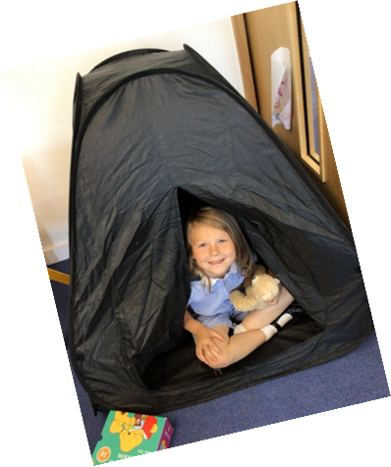
William Morris Primary School is a friendly, happy and inclusive place where children are known and cared for. Teachers and pupils treat each other with respect and kindness, which allows children to be challenged, helping them to persevere and achieve their potential. 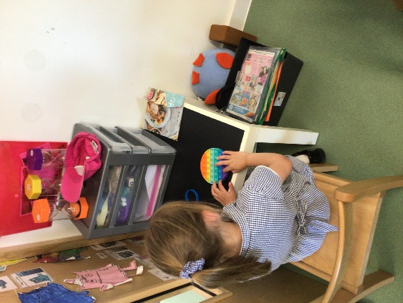

We believe in teaching skills, sharing knowledge and building special memories that children will take with them through the rest of their lives.
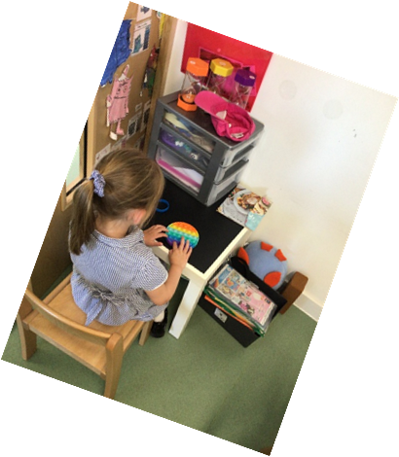
Our curriculum is creative and enables children to explore in different ways – using hands on experiences and interesting stimuli. We believe in innovative teaching that engages pupils’ interests and inspires a love of learning. Our Life Skills Curriculum ensures children are taught personal development and become all rounded citizens.

At William Morris Primary School, all pupils are equally valued. We aim to provide an exciting and inspiring, balanced curriculum for all children, whatever their ability or need. Every teacher is a teacher of every child, including those with a special educational need or disability.

We offer a full curriculum that is inclusive to all children, whatever their needs. The teaching staff work with the SENDCo to ensure they support the children academically, physically and socially. The school maintains a very close working relationship with children, staff, parents and outside agencies.

All staff are trained to deal with a wide range of individual needs, to ensure all children are treated equally. The school, in consultation with the Governing Body, will review the provision for children with SEND every year. Parents will always be closely involved in all aspects of special provision.

Can pupils with SEN have access to all activities?
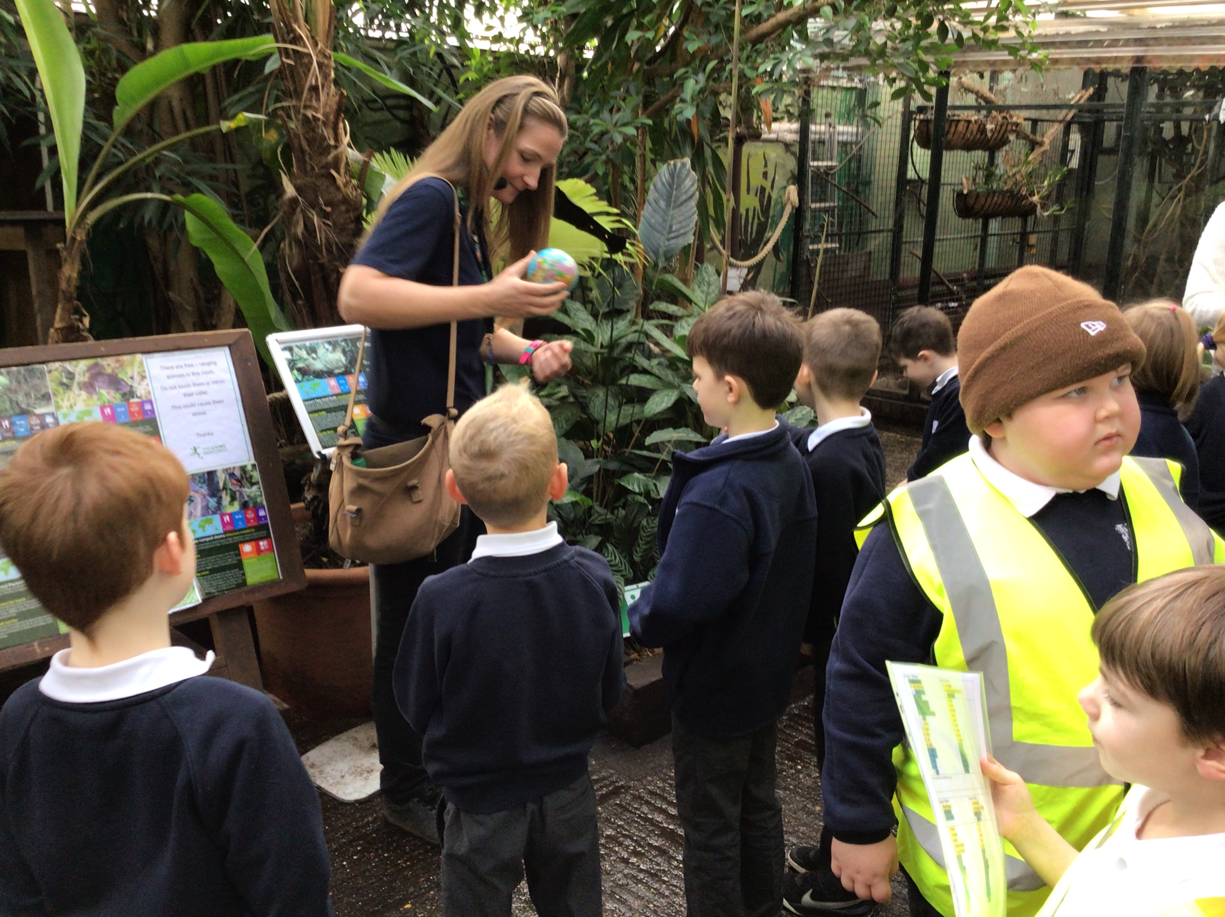
All our extra-curricular activities and school visits are available to all our pupils.
All pupils are encouraged to go on our residential trip(s) and class trips and risk assessments will be completed to address any concerns.
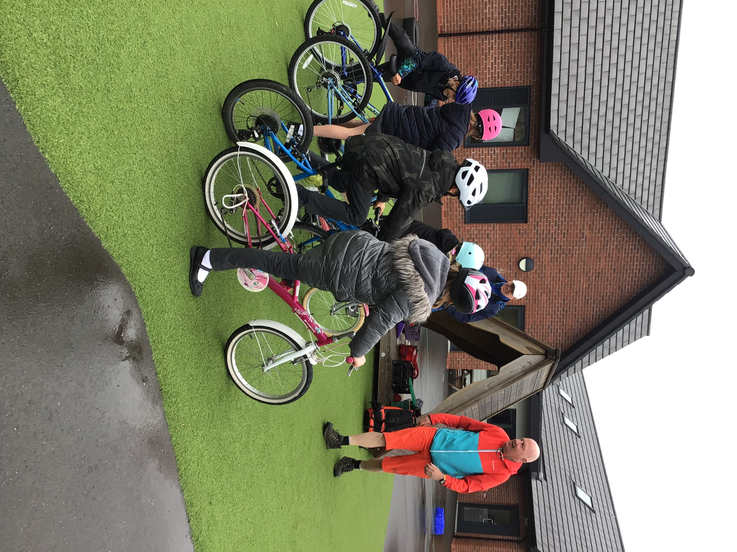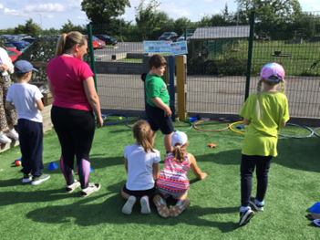All pupils are encouraged to take part in sports day (and swimming), school plays, special workshops (such as Bikeability) and can become a part of the school council.
No pupil is ever excluded from taking part in these activities because of their SEN or disability. If a child has a disability, then the school is fully inclusive. All classrooms can be accessed from the school playground.
Bikeability
Our Quiet Sports Day – children can choose to attend this instead of, or as well as, our whole school Sports Day.

What expertise and training of staff takes place at William Morris to support children with SEND?
Our SENDCo, Mrs Day, has achieved the NASENCO PGCE. She works closely with SENDCos in the Blue Kite Trust, attends SEND BRICKS meetings, SENDCo network meetings and conferences, to keep up to date on training and the latest information.
All teachers and TAs receive in-house training from the SENDCo and outside professionals on supporting children with SEND. Areas of development are identified through Teacher and TA appraisals, monitoring of the impact of interventions and booster sessions, observations of teachers and TAs and pop-ins.

Implemented a range of new interventions including Lego Club.
2022-23

Staff worked with Crowdy’s outreach support for specific children.
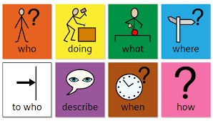Two support TAs were trained in Sign-a-long.
Colourful Semantics is a system for colour coding sentences according to the role of different words. It can help children to break down sentences and understand the individual meaning of each word and it's role in the sentence.
The Lighthouse Early Intervention Support Team worked with staff supporting children with significant SEMH needs.
One TA was trained in delivering the colorful semantics intervention by the Speech and Language Team.
Additional staff members were trained in Team Teaching.

All teachers and TAs were trained in dyslexia and dyslexic friendly strategies to teaching by the SENDCo, following on from training by ATCL (advisory teachers for cognition and learning).
2023-24

All staff were trained in Emotion Coaching. One class teacher, two teaching assistants, the SENDCo and the Senior Leadership team were trained on PACE strategies.
One TA was trained to deliver the SPARKS intervention.
The SENDCo, Nurture Nest lead and two Tas have been trained on PDA, low demand and ADHD.
One teacher and two TAs received PDA and low demand training.
Additional staff members were trained in Team Teaching.
A range of individual members of staff have had 1:1 CPD coaching around supporting children with SEND.

WHAT ARE SPECIAL EDUCATIONAL NEEDS?
A child or young person has Special Educational needs (SEND) if they have a learning difficulty or disability which calls for special educational provision to be made for them.

A child of compulsory school age or a young person has a learning difficulty or disability if they:

- have a significantly greater difficulty in learning than most others of the same age.
OR
- have a disability which prevents or hinders them from making use of educational facilities of a kind generally provided for others of the same age in a mainstream school. A child under compulsory school age has special educational needs if they fall within the definition at a) or b) above or would so do if special educational provision was not made for them

(Clause 20 Children and Families Act 2014).
There are four prime areas of Special Educational Needs:

C&I
Communication and interaction - speech and language difficulties, social communication and interaction difficulties, Autism, developmental language disorder (DLD)

C&L
Cognition and learning - including moderate Learning Difficulties (MLD), Specific Learning Difficulties (SPLD), Severe Learning Difficulties (SLD)

Social, Emotional and Mental Health needs (SEMH) – attachment difficulties, attention deficit hyperactivity disorder (ADHD), attention deficit disorder (ADD), anxiety and social and emotional developmental delay.

SEMH

PS
Sensory and/or physical needs – hearing loss, visual impairments, hearing impairments, sensory processing difficulties and physical difficulties.

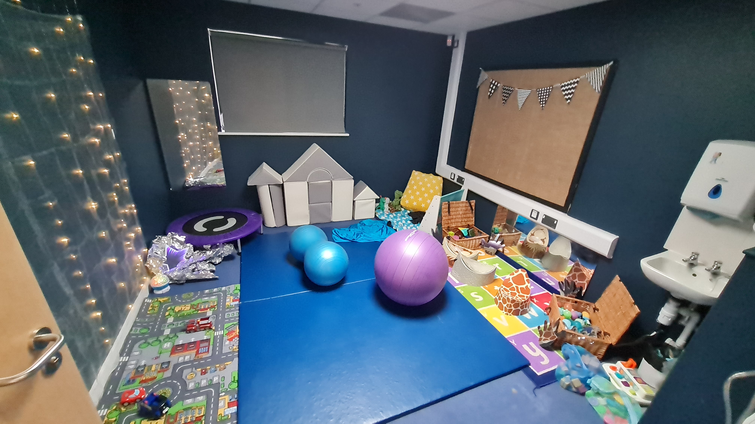
Our Sensory Room – a quiet space where children can come to help meet their sensory needs, impacting positively on their ability to regulate their emotions and focus on their learning.

COMMUNICATION AND INTERACTION
Communication and interaction has two main subcategories, as per the Code of Practice:

SLCN
Children and young people with speech, language and communication needs (SLCN) have difficulty in communicating with others. This may be because they have difficulty saying what they want to, understanding what is being said to them or they do not understand or use social rules of communication. The profile for every child with SLCN is different and their needs may change over time. They may have difficulty with one, some or all of the different aspects of speech, language or social communication at different times of their lives.

Children and young people with ASD, including Asperger’s Syndrome and Autism, are likely to have particular difficulties with social interaction. They may also experience difficulties with language, communication and imagination, which can impact on how they relate to others.*

ASD

* please note, this is taken directly from the Code of Practice. Asperger’s Syndrome is no longer given as a diagnosis and instead would now be diagnosed as autism. In general, the Autistic community prefers identify first terminology, i.e. ‘autistic child’ rather than ‘child with autism’. As a school, we will use this language unless a parent or child expresses a different preference.

What do we do as a school to support children with C&I difficulties?
Outlined below are examples of the support we would put in place for children with C&I difficulties. However, we are always led by the child and their individual needs.
Quality first teaching:
- A communication friendly environment that includes the use of signing/ symbols and other visual support if needed
- Visual Supports
- Differentiated use of language, instructions in short chunks, extra processing time
- Staff modelling correct language use
- Staff modelling interactions with a peer through play
- A quiet work environment within the classroom or resources to reduce sensory distractions such as ear defenders or a work screen if needed
- Use of talk partners to rehearse what you want to say.
- High quality staff interactions
- Alternative methods of communicating such as gestures, visuals
- 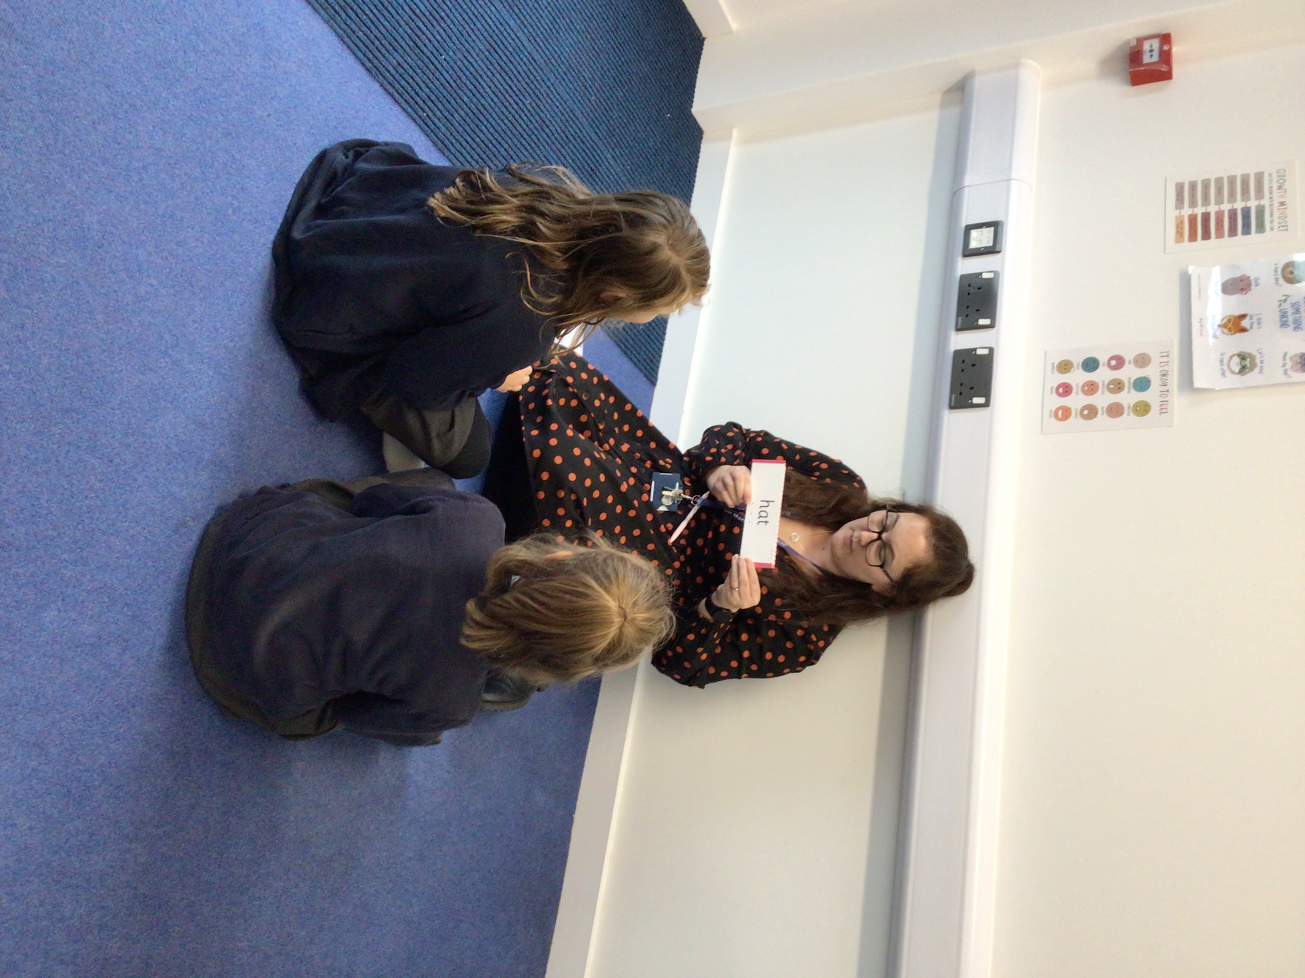Specific teaching of general listening, attention, communication and interaction skills
Our phonics scheme, Little Wandle, includes Rapid Catch Up sessions to help support children to keep up with their peers
- A calm, ordered learning environment that supports listening, attention and communication
- High quality phonics teaching
- Small group adult led interventions modelling language and interactions
- Opportunity to use quieter entrance to school and/or be met by a familiar adult
- Strategies, resources and targeted support to help them to manage the sensory and social demands of the classroom e.g. sensory breaks, access to a quiet work area, a time out card, a sensory box

Interventions and support for children with SLCN:

- Colourful semantics
- Speech and Language support
- Language for Thinking
- Language for Behaviour and Emotions

Interventions and support for children with Social Communication needs:

- Time to Talk
- Intensive interactions
- Jewellery Club
- Lego Club

- Referrals to SASS (Swindon Autism Support Service)
What has the impact of these been at William Morris?
- Children have been discharged from Speech and Language support
- Children have made accelerated progress in their Speech and Language development
- Children feel confident to communicate socially in their preferred way
- Children are able to regulate their sensory input with support
- Children increase their access to quality first teaching as they are able to access their learning environment

Useful links:
Swindon’s SALT services: https://www.swindon.gov.uk/info/20223/speech_and_language_therapy
Whole School SEND information on Communication and Interaction: https://www.wholeschoolsend.org.uk/page/communication-and-interaction

COGNITION AND LEARNING
As per the Code of Practice, Cognition and Learning can be divided into the following (taken from the Department of Education and Skills, 2003):
Pupils with MLD will have attainments well below expected levels in all or most areas of the curriculum, despite appropriate interventions. Their needs will not be met by normal differentiation and the flexibilities of the National Curriculum.
Pupils with MLD have much greater difficulty than their peers in acquiring basic literacy and numeracy skills and in understanding concepts. They may also have associated speech and language delay, low self-esteem, low levels of concentration and underdeveloped social skills.

MLD

Pupils with severe learning difficulties have significant intellectual or cognitive impairments. This has a major effect on their ability to participate in the school curriculum without support. They may also have associated difficulties in mobility and co-ordination, communication and perception and acquisition of self-help skills. Pupils with SLD will need support in all areas of the curriculum. They may also require teaching of self-help, independence and social skills. Some pupils may use sign and symbols but most will be able to hold simple conversations and gain some literacy skills.

SLD

Pupils with PMLD have severe and complex learning needs, in addition they have other significant difficulties, such as physical disabilities or a sensory impairment. Pupils require a high level of adult support, both for their learning needs and also for personal care. They are likely to need sensory stimulation and a curriculum broken down into very small steps. Some pupils communicate by gesture, eye pointing or symbols, others by very simple language.

PMLD

SpLD is an umbrella term which indicates that pupils display differences across their learning. Pupils with SpLD may have a particular difficulty in learning to read, write, spell or manipulate numbers so that their in these areas is below their performance in other areas. Pupils may also have problems with short term memory, organisational skills and co-ordination. Pupils with SpLD cover the whole ability range and the severity of their impairment varies widely.

SpLD

Diagnoses that might come under C&L:
Dyslexia
Dyspraxia
Dyscalculia

What do we do as a school to support children with C&L difficulties?
Outlined below are examples of the support we would put in place for children with C&L difficulties. However, we are always led by the child and their individual needs.

Quality first teaching:
- quality first multisensory teaching
- structured phonics/ reading/ spelling/maths programmes either whole class, small group
- resources such as pencil grips, writing slopes, aids to support spacing between words
- resources to support independent learning such as spelling dictionaries, spell checkers, alphabet strips, phonics mats, High Frequency Word mats, working walls, number lines/squares, concrete maths apparatus
- opportunities to recap learning
- adapted and acceptable tasks
- short bursts of focused adult support to reinforce understanding
- strategies and resources to support short-term working memory difficulties e.g. a mini whiteboard to bullet point instructions, a visual timetable, now and next board if needed
- strategies and resources to support organisation for tasks such as a visual timer, writing frames, mind maps
- brain breaks and movement breaks

Interventions and support:

- Precision teaching
- Pre-teaching
- Plus 1
- Power of 2
- Hands on Maths
- Little Wandle Catch Up
- Maths meetings
- CLASS referrals
- Rapid Writer
- Nurture Nest

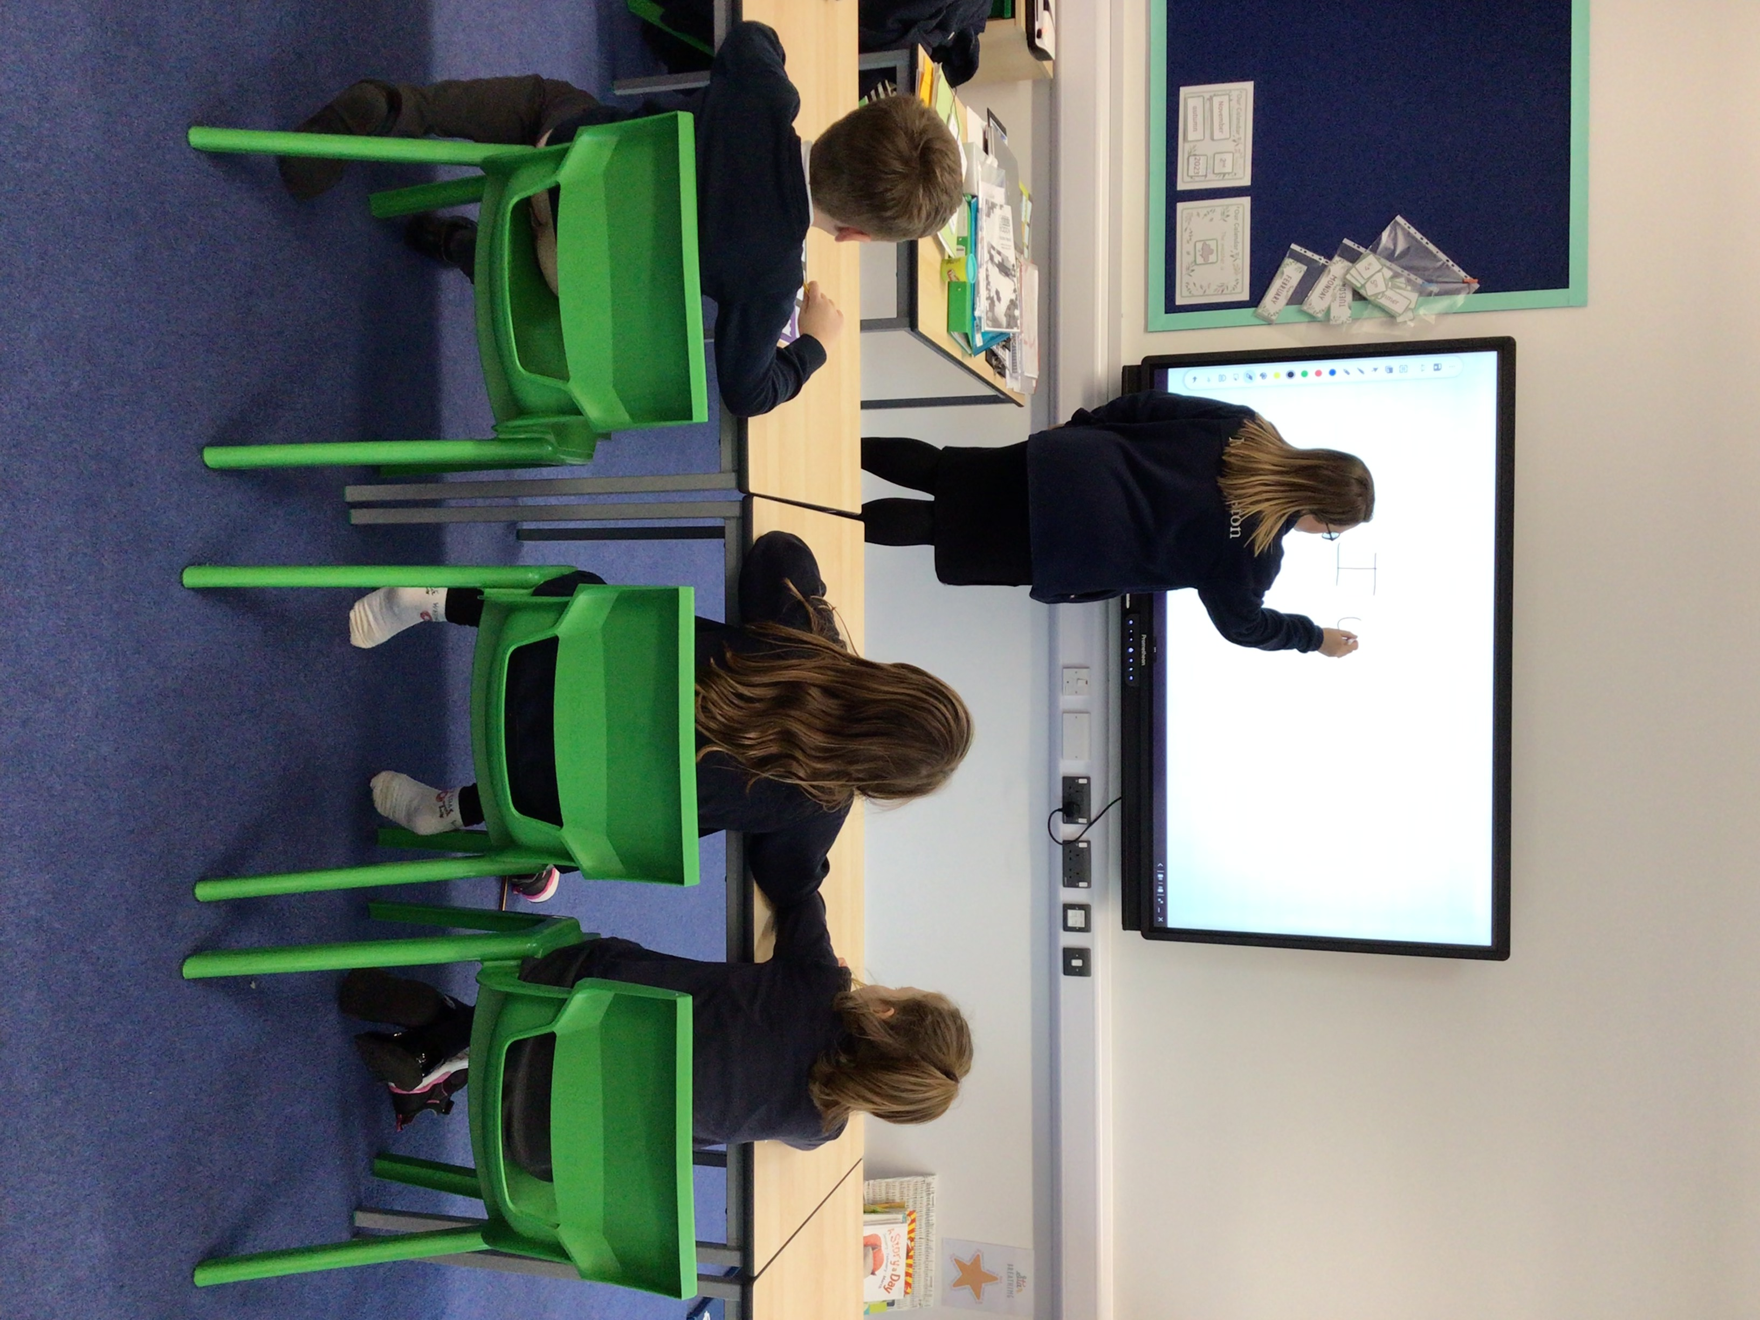
What has the impact of these been at William Morris?
- Teachers address misconceptions
- Children achieve targets (such as sound/number learnt on prevision) and move on
Rapid Writing Intervention – this has had a really positive impact on children’s confidence and progress in writing
- Children make expected progress

Useful links:
Whole School SEND information on Cognition and Learning: https://www.wholeschoolsend.org.uk/page/cognition-and-learning

SOCIAL, EMOTIONAL and MENTAL HEALTH
As per the Code of Practice, SEMH can include:
Anxiety
Displaying unexpected or distressed behaviours
Being withdrawn or isolated
Depression
ADHD
Substance misuse
Self-harming
Attachment disorder
Eating disorders

What do we do as a school to support children with SEMH difficulties?
Outlined below are examples of the support we would put in place for children with SEMH difficulties. However, we are always led by the child and their individual needs.

Quality first teaching:
- All children at William Morris identify three trusted adults. Staff are aware of each child’s trusted adults and these are considered in a pastoral capacity when children need to discuss any SEMH needs, including bullying (please see our anti-bullying policy for more information)
- structured emotional literacy teaching including short term social support
- calm, structured, well-organised classroom environment
- a safe space to use in times of dysregulation/overload
- clear behaviour targets that are praised/rewarded when achieved
- staff modelling and reinforcing specific social skills and emotional literacy skills
- 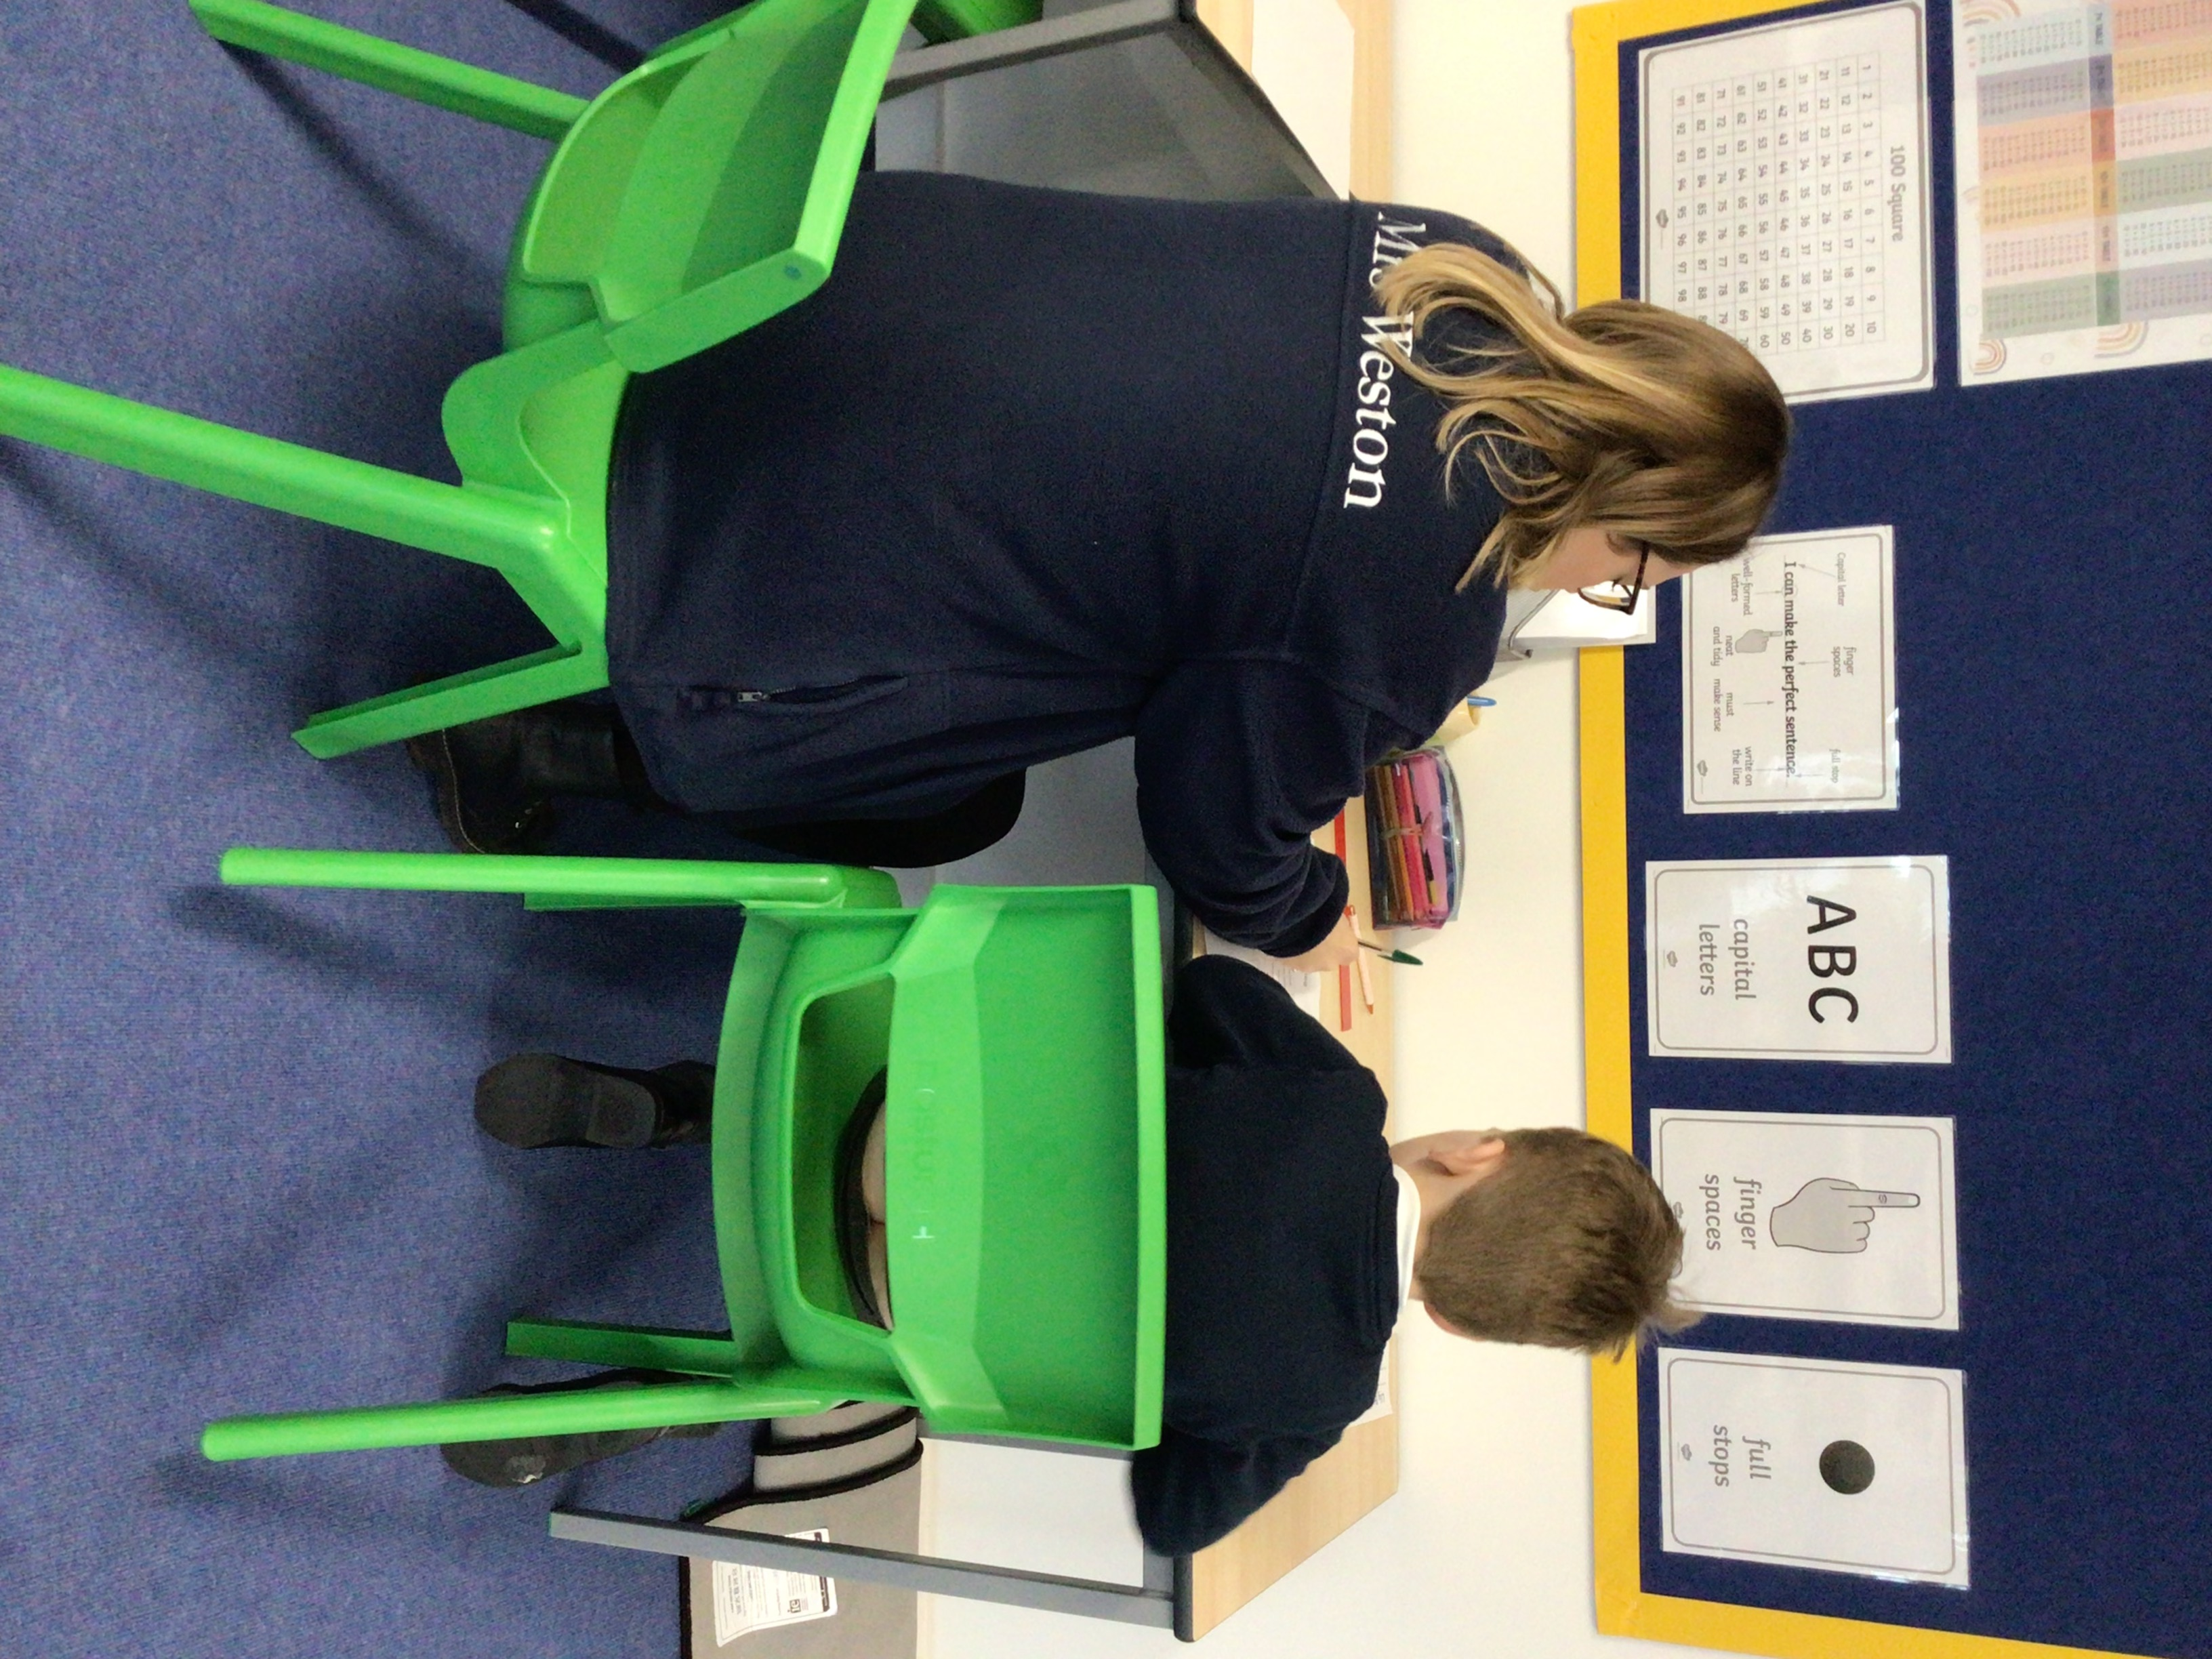a Buddy/befriender system or similar at play and lunch times
Our Nurture Nest provides a quiet, communal space for children to work to support their focus.
- access to a quiet work area or resources to support focus and attention such as ear defenders, a wobble cushion/stools or a work screen
- movement breaks
- Therabands
- high-quality relationship with staff
- short term check-ins with adults
- all staff understand the principles behind a trauma informed approach
- high quality PSHE lessons to promote understanding of emotions and relationships
- worry boxes, regularly checked

Interventions and support:

- ELSA
- Trauma informed HLTA
- Nurture Breakfast
- Quiet lunch
- Yoga
- De-escalation plans
- Nurture Nest
- Drawing and talking
- Lighthouse play therapy
- BeU
- STEP
- Anger Blanket
- Family Support Worker

What has the impact of these been at William Morris?
- Children are supported with SEMH needs and progress is made in school and with outside agencies.
- Children are supported to reduce anxiety and build resilience and self-esteem, allowing them to access their learning.

5 Steps to Mental Wellbeing
https://youtu.be/x6bz_ekkrYA
The five ways to well-being are:
Connect - connect with people around you.
Be active - find an activity that you enjoy and make it a part of your life.
Keep Learning - learning new skills can give you a sense of achievement and a new confidence.
Give to others - even the smallest can count, whether it is a smile, a thank you or a kind word.
Be mindful - be more aware of the present moment, including your thoughts and feelings, your body and the world around you. Some people call this awareness 'mindfulness'. It can positively change the way you feel about life and how you approach challenges.

Useful links:
Whole School SEND information on SEMH: https://www.wholeschoolsend.org.uk/page/social-emotional-and-mental-health
Anna Freud is a world-leading mental health charity
NHS Every Mind Matters Wellbeing Tips
BeU – Advice for Parents
Short films from the NHS Series of short films about healthy family communication and how to support young people who are struggling with their wellbeing and mental health
Mind – Mental Health Charity
Action for Happiness
Swindon Healthy Schools
Swindon Mental Wellbeing Support Page
Lift Psychology – a resource that provides self-help resources as well as online counselling and therapy sessions

PHYSICAL AND SENSORY
“Some children and young people require special educational provision because they have a disability which prevents or hinders them from making use of the educational facilities generally provided. These difficulties can be age related and may fluctuate over time.” (Code of Practice, 2015)

This can include, but is not limited to:

VI

MSI
Multi-sensory Impairment

HI
Hearing Impairment
Vision Impairment

What do we do as a school to support children with PS difficulties?
Outlined below are examples of the support we would put in place for children with C&L difficulties. However, we are always led by the child and their individual needs.

Quality first teaching:
- carefully considered placement within the classroom to minimise distractions, support listening, ensure adequate and appropriate lighting and a direct line of sight for the child to the teacher/support staff
- a well-organised learning environment with minimal clutter
- a learning environment with comfortable lighting and minimal glare
- a calm, quiet learning environment, reducing background noise
- visual supports for teaching and organisation
- appropriate focused adult support as needed to check understanding of instructions and teaching
- a Buddy/befriender system or similar at play and lunch times to support social inclusion and H&S
- an adult who understands and can support with managing and troubleshooting hearing aids
- a quiet work area if needed
- large print resources with good quality print and good contrast
- resources with minimum visual clutter
- extra time to complete tasks and ‘down time’ to reduce the effects of visual fatigue
- short bursts of focused adult support to check understanding of instructions and teaching
- pencil grips or writing slopes if required to support their writing
- alternative methods of recording,
- support to cut up food and to open packets and containers if required
- access to adapted cutlery if they need this
- access to disabled access toileting facilities if necessary in line with the Equality Act 2010
- support to develop toilet training skills and personal care independence skills if needed
- a standard chair to avoid floor sitting in class or in assembly
- basic support to assist pupils with changing for PE lessons e.g. doing up shoe laces
- if needed simple adaptations to the P.E/ sports curriculum including participation in Sporting events/trips
- support to help pupils to put on or remove simple therapy equipment e.g. lycra gloves or ankle / foot orthotics
- regular monitoring of a medical condition such as diabetes blood tests
- Intimate care plans in place as required

Interventions and support:

- SPARKS/SPARKEY
- Fine motor interventions
- Gross Motor interventions
- Yoga
- Sensory Room

What has the impact of these been at William Morris?
- Children have the chance to improve their pencil grip and control, impacting on handwriting.
- Children with gross motor needs develop these skills.
- Children with sensory needs have these met to help with emotional regulation.

Useful links:
Whole School SEND information on Cognition and Learning: https://www.wholeschoolsend.org.uk/page/sensory-and-physical

OUR PROCESS
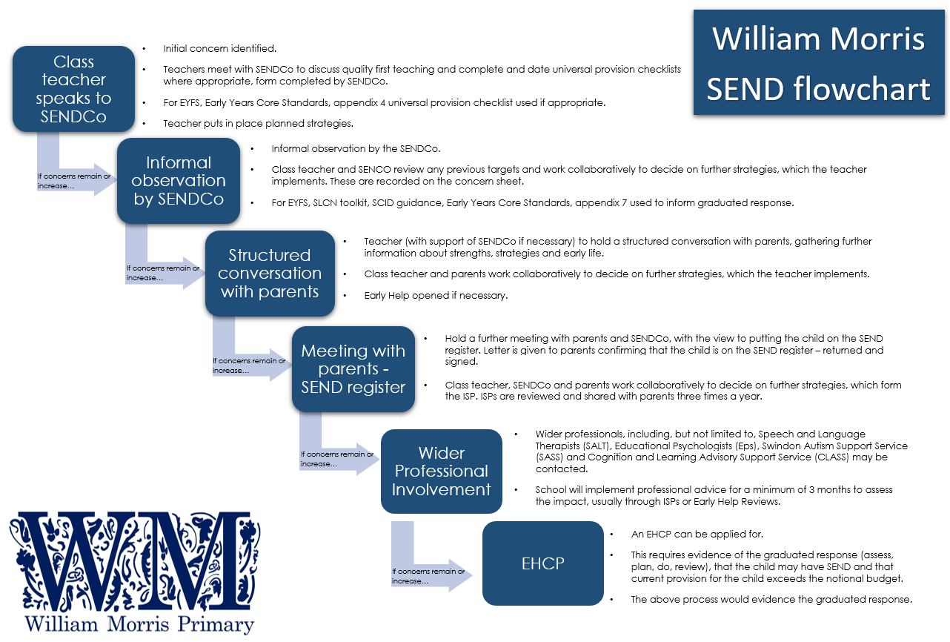
Who do I contact if I have concerns?
In the first instance, parents/carers are encouraged to raise any concerns they have with the class teacher during designated times (such as parent consultations) or request a meeting.

If concerns continue, parents will be invited to meet with the class teacher(s) and SENDCo, Mrs Emily Day, to speak about their child’s additional needs.

Please either speak to your child’s class teacher or contact the school office on 01793 299022 or email admin@williammorris.bluekitetrust.org to arrange a meeting.

How does the school identify children with SEND?

As a school, we are guided by Swindon’s Core Standards and our flowchart to help us identify if a child may have special educational needs.

We assess each pupil’s current skills, levels, and progress continuously. Examples of when a pupil may be identified as needing extra help are if they are:
- Working significantly lower than age related expectations
- Identified through pupil progress tracking as making little or no progress.
- Being affected by low self-esteem or behaviour
- Having significant difficulties communicating their wants, needs and ideas

Slower progress and low attainment will not automatically mean a pupil is recorded as having SEND. Parents will be invited to a meeting to discuss whether their child is placed on or removed from the school SEND register as part of our response to SEND, and provided with a letter to help explain these processes.

Quality First Teaching

All teachers are teachers of SEND and are responsible and accountable for the progress and development of all the pupils in their class. High quality teaching is our first step in responding to pupils who have SEND. The DfE Code of Practice (2015) states:

“High quality teaching that is differentiated and personalised will meet the individual needs of the majority of children and young people. Some children and young people need educational provision that is additional to or different from this. This is special educational provision under Section 21 of the Children and Families Act 2014. Schools and colleges must use their best endeavours to ensure that such provision is made for those who need it. Special educational provision is underpinned by high quality teaching and is compromised by anything less.”

In practice, high quality teaching includes (but is not limited to):
- ensuring lessons are planned meet the needs of all learners
- adaptive teaching; in the moment assessment of children’s ability to support and challenge
- the use of modelling, scaffolding and questioning
- use of individual, small group and whole task discussions
- use of positive praise and whole school behaviour management

The SENDCo and Senior Leadership Team carry out regular monitoring, including pop-ins, intervention folder monitoring and book looks to ensure the classrooms are set up to create the best learning environments for all children.

Pupil voice sessions and a yearly parent questionnaire also contribute to evaluating the effectiveness of provision made for pupils with SEND.

Pupils who are looked after by the local authority

Looked after children have a Personal Education Plan and regular meetings with carers, social workers, the Virtual Head Teacher for looked after pupils, class teacher, SENDCo and our school designated teacher for looked after children. The child’s views are gained before the meeting and where appropriate the child is invited to join the meeting. The PEP sets out goals and actions with associated costs which ensure the pupil’s allocated LAC funding is spent correctly.

ASSESS PLAN DO REVIEW
We follow the guidance in the Special Educational Needs Code of Practice (2014). This recommends a Graduated response to SEND which comprises of four stages, Assess, Plan, Do and Review.

We assess and analyse a child’s needs and work in partnership with parents/careers and children, where appropriate, to gain a deeper understanding of the potential barriers to learning.
ASSESS

The aim of parent/carer conversations is to ensure that:
- we learn the valuable information that you hold about your child.
- we develop a good understanding of the pupil’s strengths and needs.
- everyone understands the agreed outcomes and next steps
- we work as a team to support your child.

PLAN
The needs of children with SEND are considered on an individualised basis and they are planned for accordingly. ISPs (Individual Support Plans) will be written for children on the SEND register who need a variety of additional support.

- Children and parents will be involved in writing this process ISPs and can contribute their aims and wishes for the year, as well as the children’s strengths and how they like to learn.
- Clear, precise and achievable targets will be set.
- These will be assessed, reviewed and shared with parents as part of the graduated response to SEND three times a year – at the end of the Autumn, Spring and Summer terms.

Class teachers will work closely to plan and monitor the impact of interventions and to make links with the classroom. The SENDCo will be on hand to problem solve when needed.

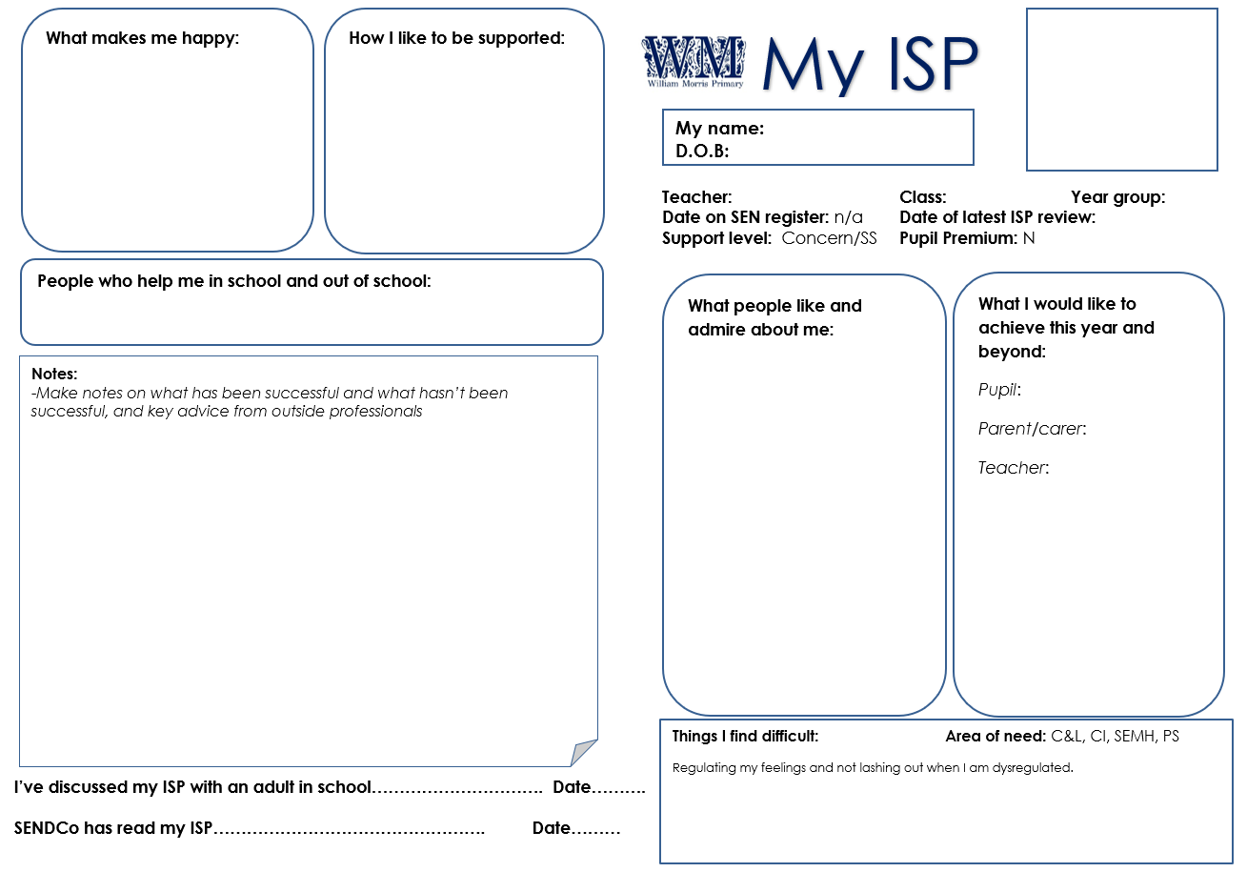

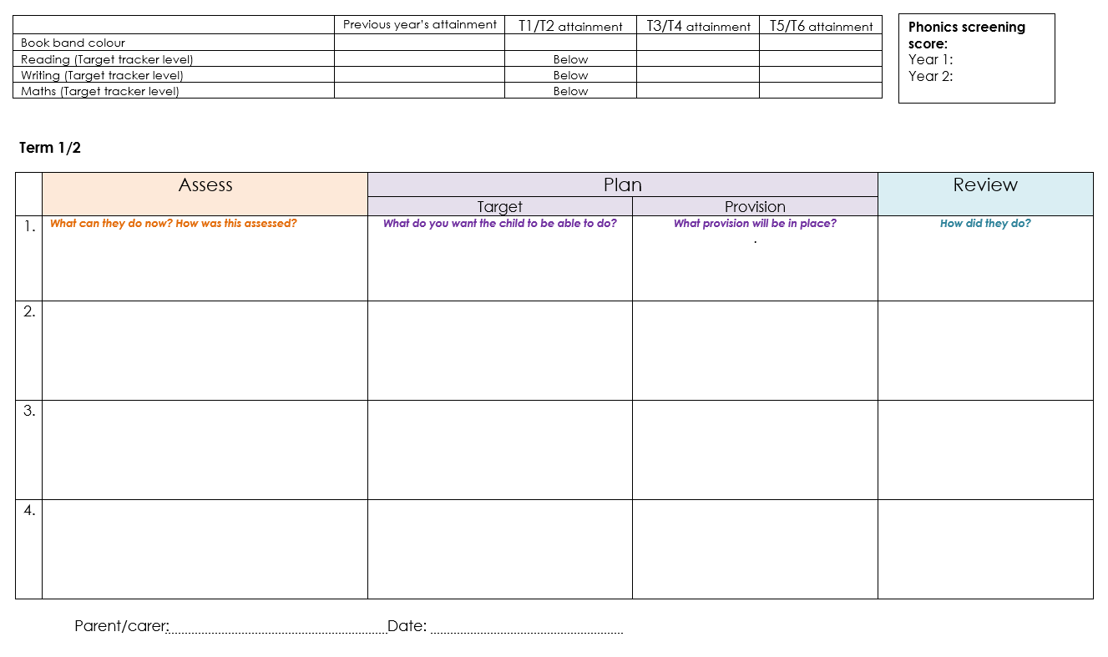Our ISP template

DO

Children with SEND are taught to be independent, to use strategies to support their needs and are given the love of learning that we hope all our children leave our school with.

Interventions utilised at William Morris Primary are evidence based. Records are kept in each year group’s intervention folder. Interventions are evaluated to ensure they are effective and adapted in a timely fashion where needed.

The class teacher remains responsible for working with the child on a day-to-day basis and retains responsibility for any interventions run.

A wide range of additional strategies and approaches can be utilised. Examples of these include, but are not limited to:

Adapting the teaching and curriculum
e.g. groups sizes, 1:1 work, learning style, resources, visual aids, pre-teaching of key concepts etc.

Using recommended aids
e.g. alternative methods of recording, visuals, practical resources, Now and Next boards, larger font etc.

Delivering specific interventions
e.g. Talk Boost, ELSA, Play Therapy, catch up programs, Time to Talk, SPARKS, Hands On Maths, Rapid Writer, Little Wandle Phonics interventions, Language for Thinking, Language for Behaviour and Emotions, Precision reading

Delivery booster groups
e.g. extra phonics, fine motor, writing groups

Example of interventions, their linked area of need and their impact.
Reviews of a child’s progress will be ongoing. ISP targets will be reviewed to evaluate the impact on progress; the class teacher and in some cases, the SENDCo, will look at what has been and what has not been successful and why.
REVIEW

The child will be asked how they feel about learning and what helps them to learn. This is age and ability dependent. We also seek the views of parents.

In addition, pupil progress meetings are held three times a year; children not making sufficient progress are identified and discussions with year group teachers take place to discuss possible barriers and next steps. Good practice is shared and any areas of concern are addressed rapidly.

WHAT NEXT?
Outside Agencies
Sometimes a pupil may need support from an outside agency. If this is needed, this will be discussed with the parent and parental consent will be required in proceed. We work with the following agencies, amongst others:

- Blue Kite Lighthouse Service
- Blue Kite Educational Psychologist
- Play Therapists
- Cognition & Learning Advisory Support Service (CLASS)
- Swindon Autism Support Service (SASS)
- Hearing Support team
- Visual Impairment team
- Educational Psychology Service
- Educational Welfare Officers
- Social Services
- Parent Support Advisor
- School Nurse
- BeU
- Speech and Language Therapy
- Occupational Therapy
- Outreach/Inreach from specialist provisions.
- Early Help Hub

Educational Health and Care Plans

If a child’s needs cannot be met by the afore mentioned provision, it may mean that they require an Education Health Care plan. School or parents can apply for an EHCP. More information can be found on the Swindon Local Offer.

If a child has an EHCP then parents and professionals will be invited to contribute to and attend a yearly annual review. Regular contact will be kept with parents throughout the school year. The child’s views will be sought before each meeting.

Special School Provision

If a child with an EHCP needs a more specialist curriculum to meet their needs, parents and carers have a right to apply for a place in a special school, where a more specialist curriculum can be delivered. This is done through the annual review process. More information can be found on Swindon’s continuum of provision.

Alternative Provision

In a minority of cases, where pupils are unable to receive a suitable education due to exclusion, illness or other reasons, Alternative Provision may be arranged by the Local Authority or school. Further information can be found in the DfE’s Alternative Provision guidance.

Supporting pupils moving between phases and preparing for adulthood

In school, we offer enhanced transitions to children on the SEND register who may find transitions challenging. This is individual to each child but can include additional visits to the class teacher, a chance to chat to children in the year above and a personalised transition booklet.

All pupils joining the school in nursery or reception will have the opportunity for a home visit or meeting at school. Where necessary, the class teacher and/or SENDCo may visit children with additional needs in their current educational setting and attend Early Help meetings.

Enhanced transition plans are made accessible for children new to the school who require extra support and we invite any prospective parents of children with SEND to contact the school office to discuss arrangements.

Pupils in year 6 will be invited to transition session in their new secondary school.

HELP, ADVICE AND SUPPORT

Where can I go for more information?
Our local authority’s local offer is published here: https://www.swindon.gov.uk/sendlocaloffer
Our contribution to the local offer can be found on the continuum of provision, located here.

The Special Educational Needs and Disability Information Advice and Support Service


SIAS offer independent advice and support to parents and carers of all children and young people with SEND.

The contact details are:
Tel: 01793 466515
Website: https://www.swindonsias.org.uk

Other helpful websites

https://swindonsendfamiliesvoice.org.uk – Swindon Send Family Voices
https://www.swindon.gov.uk/info/20220/send_newsletters/1565/send_news_splash - SEND News Splash
https://www.ipsea.org.uk/model-letters - IPSEA’s model letter page has lots of templates for use
https://www.swindoncarers.org.uk/ – as a parent of a child with SEND, you may be eligible to register as a parent carer
https://cerebra.org.uk/ - Cerebra UK has lots of advice and support to help wording your DLA application
https://www.gov.uk/apply-blue-badge
https://www.accesscard.online/- Access Cards communicate your child’s access requirements to events and venues
https://www.ceacard.co.uk/ - CEA cards allow a complimentary ticket for a carer to go to the cinema with a disabled guest
https://www.swindon.gov.uk/info/20204/leisure_and_activities/1445/short_breaks - may be able to offer support if you child is unable to access any clubs or groups without support
https://www.swindoncarers.org.uk/young-carers-support-in-swindon/ - if any siblings are acting as carers, they may be able to access respite and support from peers in a similar situation through Young Carers
https://www.gov.uk/disabled-facilities-grants - If you need to make adaptations to your house due to your child’s disability, you may be able to apply for a grant through the Disabled Facilities Grants
https://www.gov.uk/apply-council-tax-reduction - If adaptations have to take place in the house, you may be able to request a reduction in council tax

Complaints about SEN provision
Complaints about SEN provision in our school can be made to our Headteacher, Mrs Fraser and SENDCo, Mrs Day via admin@williammorris.bluekitetrust.org.

This is the first response and then if needed they will be referred to the school’s complaints policy.

The parents/carers of pupils with disabilities have the right to make disability discrimination claims to the first tier SEND tribunal if they believe that the school has discriminated against their children. They can make a claim about alleged discrimination regarding:
  - Exclusions
  - Provision of education and associated services
  - Making reasonable adjustments, including the provision of auxiliary aids and services

Monitoring arrangements
This policy and information report will be reviewed by the SENCO (Emily Day) every year. It will be approved by the governing board.

Links with other policies and documents
This policy links to our policies on

- Accessibility plan
- Anti-bullying policy
- Attendance policy
- Behaviour
- Equality information and objectives
- Supporting pupils with medical conditions

Signed: Mrs Emily Day (SENDCo)

Date: July 2024

